**Send the below email to:**

1. [ceo.office@ndis.gov.au](mailto:ceo.office@ndis.gov.au)
2. Your provider relationship officer if you have one
3. [provider.support@ndis.gov.au](mailto:provider.support@ndis.gov.au)
4. [info@intermediaries.org.au](mailto:info@intermediaries.org.au)

**Plan Management Set-Up Fees for Plan Extensions**

Attn: Dr Lisa Studdert, Mrs Gerrie Mitra and Mrs Kitsa Papadopoulos,

I am writing to you as (insert position title) of (insert company name).

As you are aware, on 22 June 2022, the NDIA published its decision and outcomes of this year’s Annual Price Review, which for the first time included a note:

*“A plan manager can only claim for the support item 14_033_0127_8_3 (Plan Management – Set Up Costs) once in respect of each plan. Auto-extended plans are not new plans – they have the same plan number. Plan managers are not entitled to make another claim for this support item from a plan when it is auto-extended.”*

For the NDIA to infer, or state that this new position ‘has always been the policy or direction’ is both wrong and deeply offensive. The NDIA has not once until the publishing of the Pricing Arrangements document effective 1 July 2022, made such statements in policy or communication.

This is a reversal of the NDIA’s previous public position on the ability for Plan Managers to claim for a further Set-Up Fee where such Set-Up and Establishment services are delivered and funding is available in a Participants Plan, which it already is when a plan is extended. I.e. Fee for service - where a Plan Manager does the work, as directed by the NDIS Participant, they get to be claim for payment of that work.

This previous position had been widely communicated to the sector through the provider engagement team, including in public presentations to the market. Further this issue was not raised in the Annual Price Review Consultation Paper or in either of the two Working Group meetings conducted for Plan Management as a part of the Annual Price Review.

The NDIA has made it quite clear in the Guide to Plan Management the differences in tasks and duties that are to be undertaken for claiming of the Set-Up fee verses the Monthly Management Fee.

For clarity below is an analysis of the task a Plan Manager needs to undertake to establish a new plan, which is paid for by an Establishment fee, versus that of a plan extension.

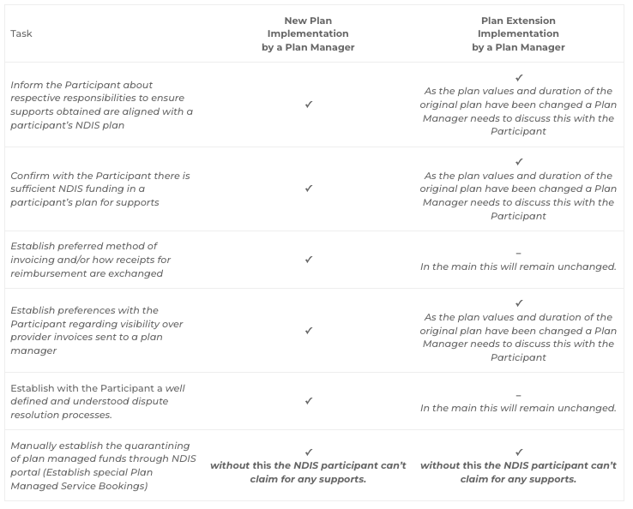

In the main, what is involved in implementing a plan extension is the same as a new plan. To say that this work does not need to be undertaken just because the Plan number remains the same in disingenuous and goes against the very principles of the NDIS.

A delegate of the NDIA, or automatic process, includes a set-up fee in the participants plan extension already (it is not an increase to plan values or a further action required by the NDIA), for this new pricing arrangement to limit the participant choice for these services to undertaken and paid for exposes the Participant and the NDIS to increased risks and poorer outcomes.

I request that the NDIA overturn and remove this note to allow Plan Managers to claim for the work they are being directed to do by both the Participant and the NDIA.

If the NDIA does not intend to reverse this decision, I request a detailed response on what steps the NDIA has put in place to undertake such set-up / implementation functions for plan extensions as Plan Managers would clearly no longer be responsible or required to deliver this work.

Regards,

(Insert your email signature)